A program that generates a plot representative of Diffusion Limited Aggregation was created. This program runs until a set number of particles are aggregated to the original seed at (0,0). A new walk is generated on the seed radius and conducts random walks. The program kills the particle and generates a new walk if the particle randomly walks into the kill radius. If the particle walks until it is within sticking distance of the aggregate, it will attach and a new particle will be generated. As the size of the cluster increases, so does the seed radius and the kill radius until again the N number of particles are aggregated.

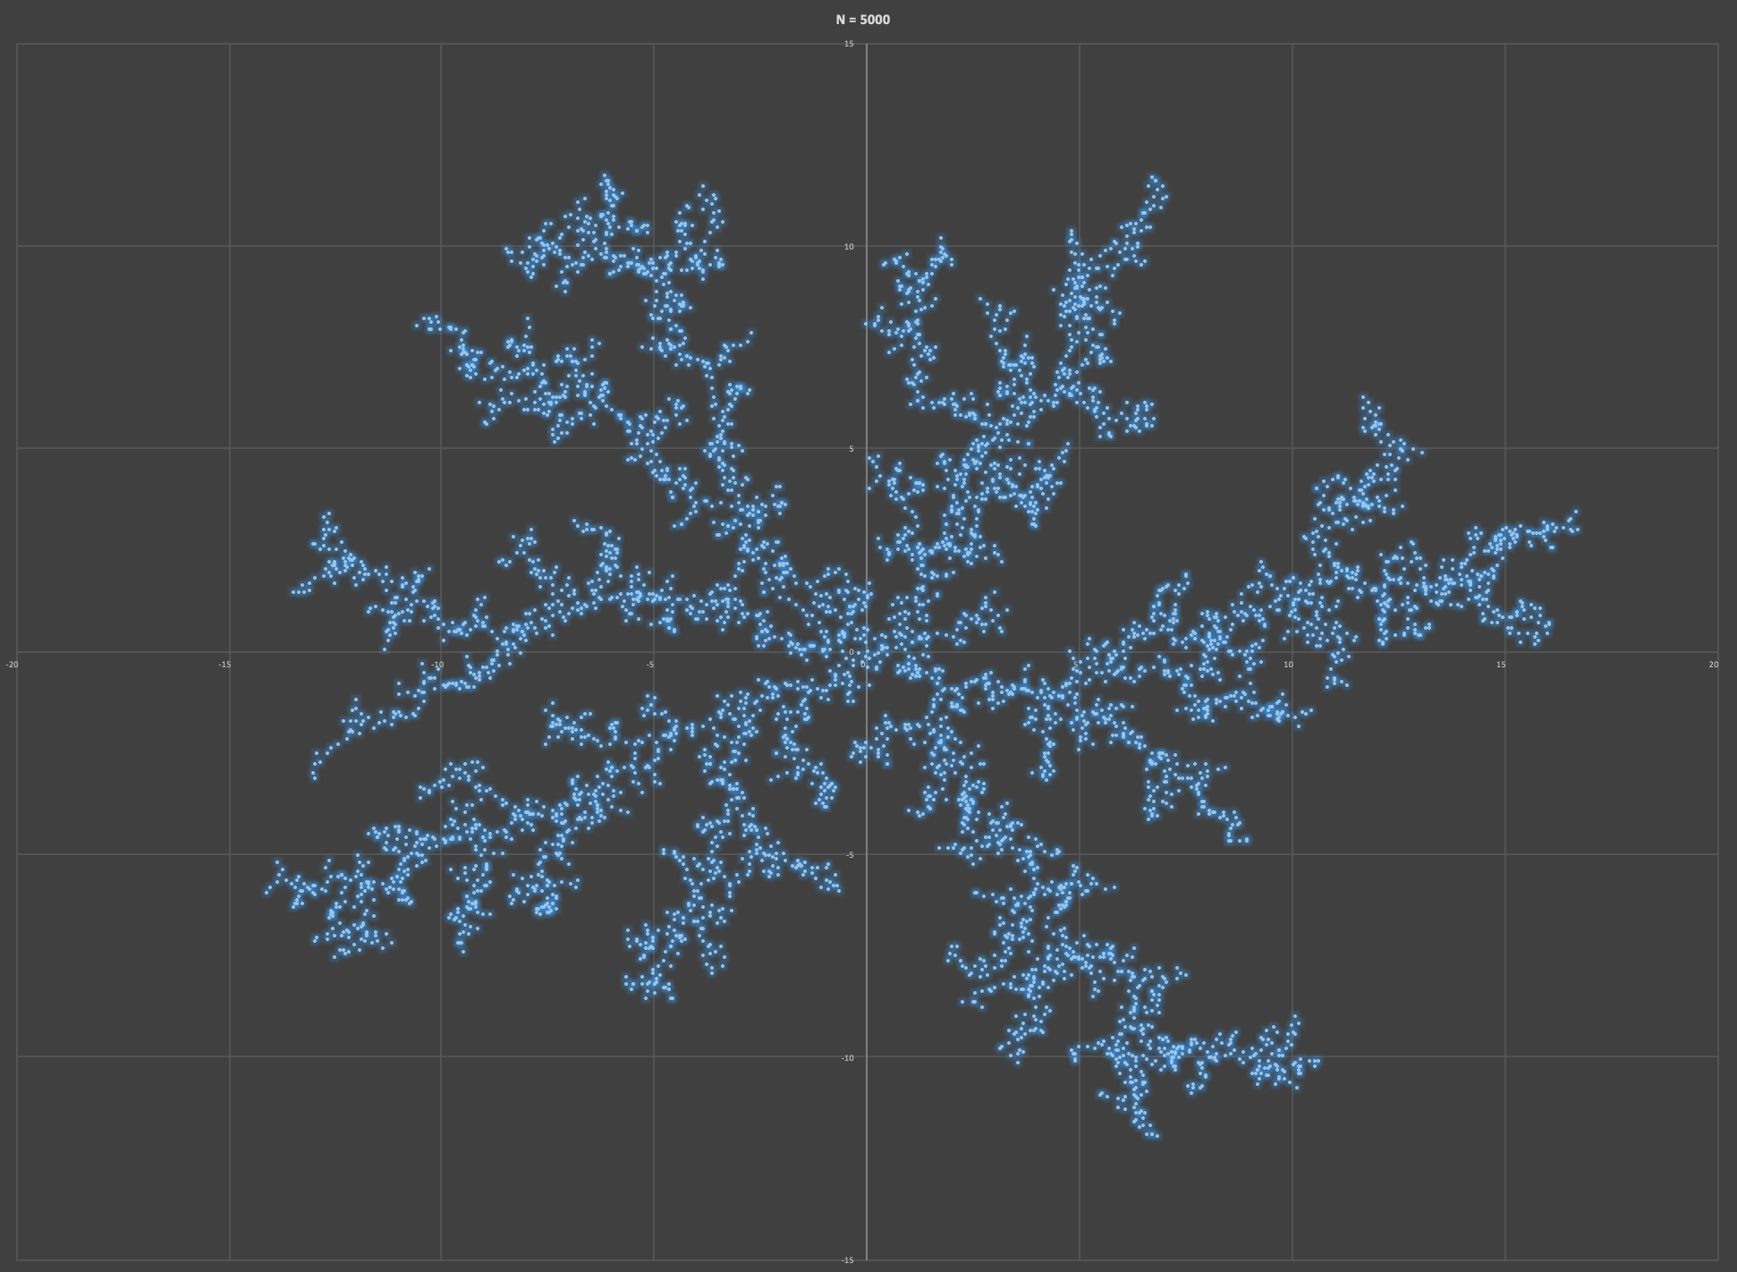

**Figure 1.** This plot is a DLA model composed of 5000 particles. I screenshotted the expanded excel graph because if I didn’t the markers would be a little to bunched up and I couldn’t decrease all the marker widths. I included a text file with all (x,y) coordinates used to scatter-plot the structure.

**Figure 2.** Plot of ln(r) vs. ln(N(r))

We can use the slope of this plot to determine the fractal dimension of our DLA. The slope of this graph before it levels off is about 1.5 so the fractal dimension is 1.5.

We could decrease the runtime of our program if we didn’t check the stick distance against every cluster particle. It is more likely a new particle sticks to the outermost particles of the aggregation, and so, it would be more efficient to check the stick distance starting with the outmost cluster particles and work our way in.